CopyData, the answer to the modern data migration needs.

When moving from legacy applications to the new advanced ones we should consider not only applications to be changed but also significant changes coming in data structure. The new data frequently has more normalized structure with stronger data integrity restrictions and copying the old data into the new data structure becomes the key problem for the success of the new application implementation. And the most complicated part of the problem is not different data formats or data locations, but changes in the data structure itself.

There are many available data conversion and data migration tools on the market. They allow using of many data formats and many types of data sources and data targets, they support many connectivity types and they claim to meet all the specialized business needs of your organization. These tools are based on the concept “One source for one target” and if you do not need data restructuring you may use them.

Unfortunately, modern data migration is much more complicated, especially when moving to an ERP systems. The base concept “One source – one target” cannot supply enough flexibility and have to be changed to the new advanced concept: “One source for many targets”.

This vital need is addressed by CopyData. You can split your source table into many destination tables in the target database with built-in referential integrity support.

The main features of CopyData are:

- Support for “One Source for many Targets” concept.
- Full usage of Source and Target DBMS’ SQL features.
- Possibility of target tables being used as data dictionaries.
- Possibility of updating for existing target rows.
- Internal customization with Counters, Constants and JScript Functions.
- Native interfaces to Sybase, MS SQL Server and Oracle databases.
- Support for ODBC data sources.
- Automatic metadata retrieval with possibility for manual metadata definition.
- Flexible friendly graphical user interface.
- Complete log of copying process.
- SQL and JScript debugging windows.

With CopyData you can create flexible and powerful data movement solutions for your advanced and modern business!

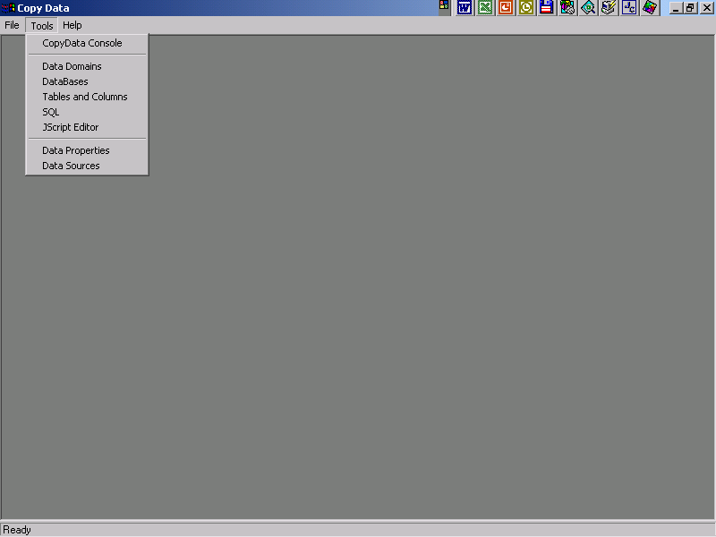

Screenshot 1.

Starting position. A user can choose to work from the Console or with individual system’s features.

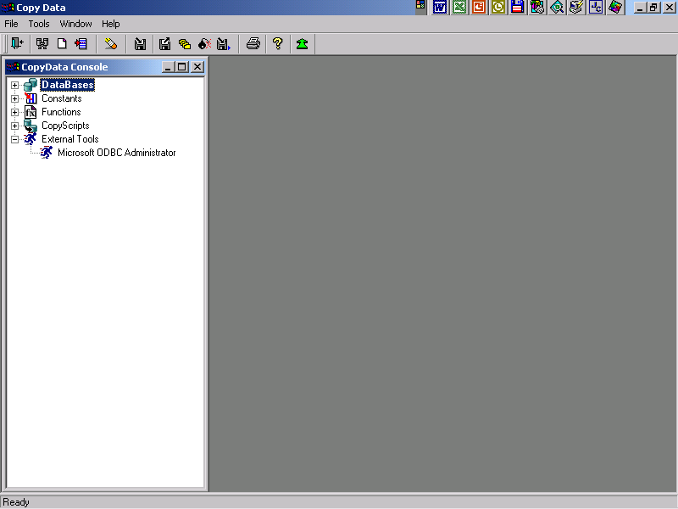

Screenshot 2.

CopyData Console. The universal access to all resources and possibilities of the system.
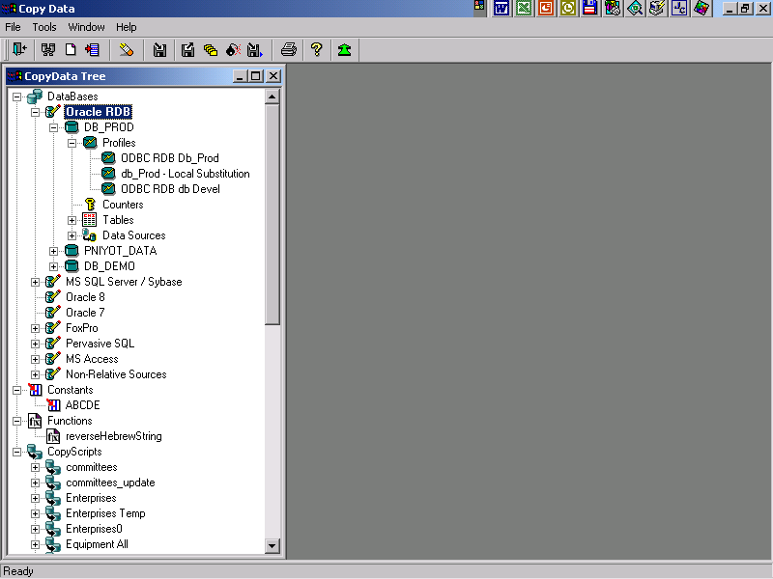

Screenshot 3.

CopyData Console. Top-level tree branches are opened.
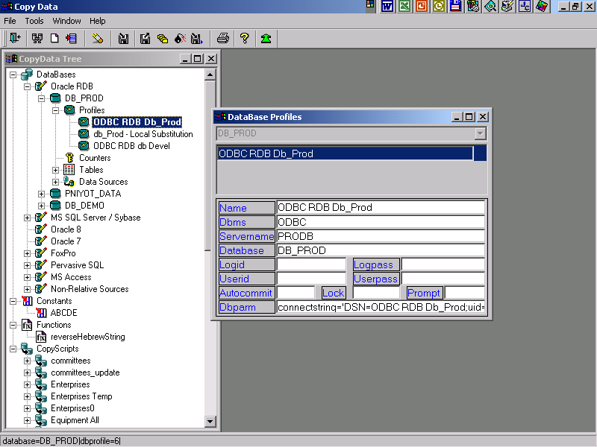

Screenshot 4.

Opening a database profile ( database connection parameters ) from the CopyData Console.
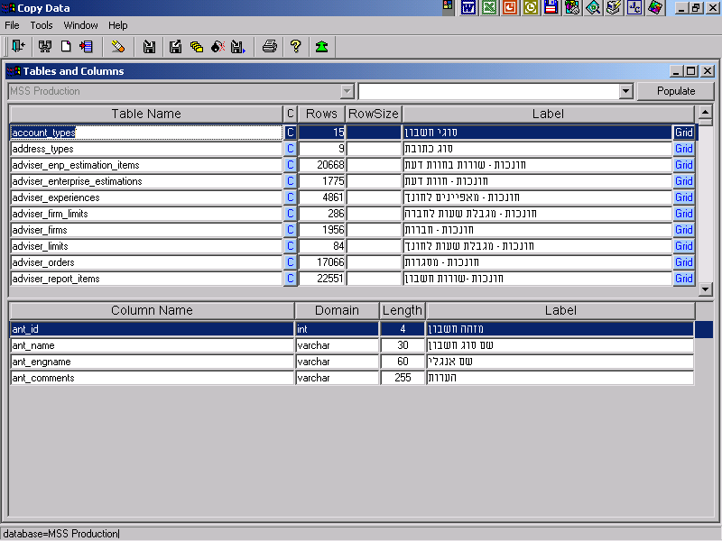

Screenshot 5.

Tables and Columns view of the specified database. The database structure can be specified manually or metadata for some database types can be retrieved automatically. This view also gives a possibility for simple grid editing of the chosen table.
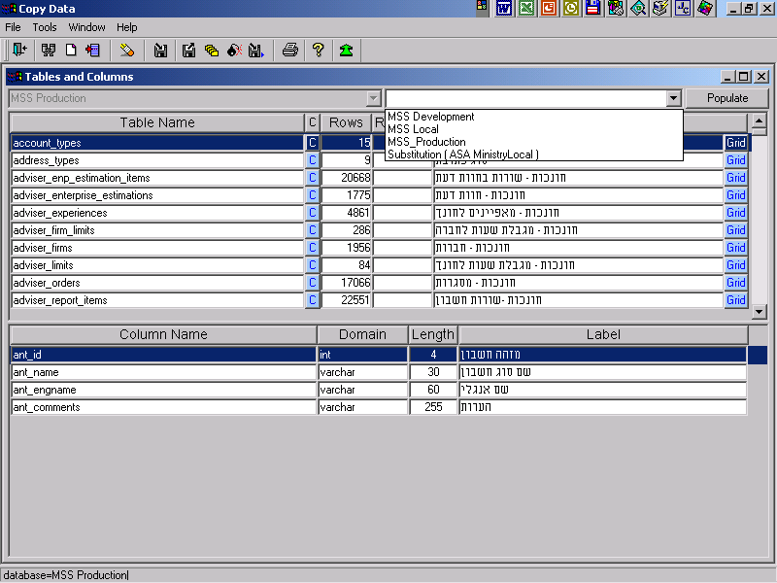

Screenshot 6.

Tables and Columns view of the specified database. A Database profile choosing.
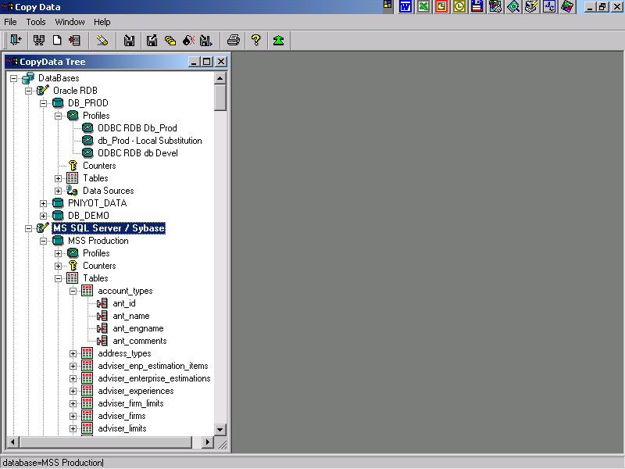

Screenshot 7.

CopyData Console. After database metadata populating it is possible to view the database structure in the Console Tree.
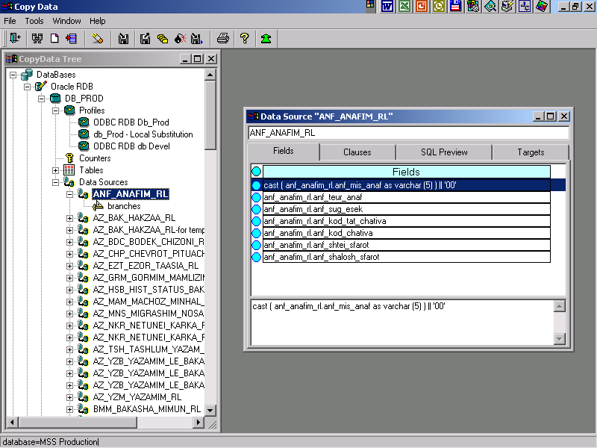

Screenshot 8.

CopyData Console. The list of Data Sources from the specified Database is populated. The chosen Data Source is opened. The “Fields” page is presented.
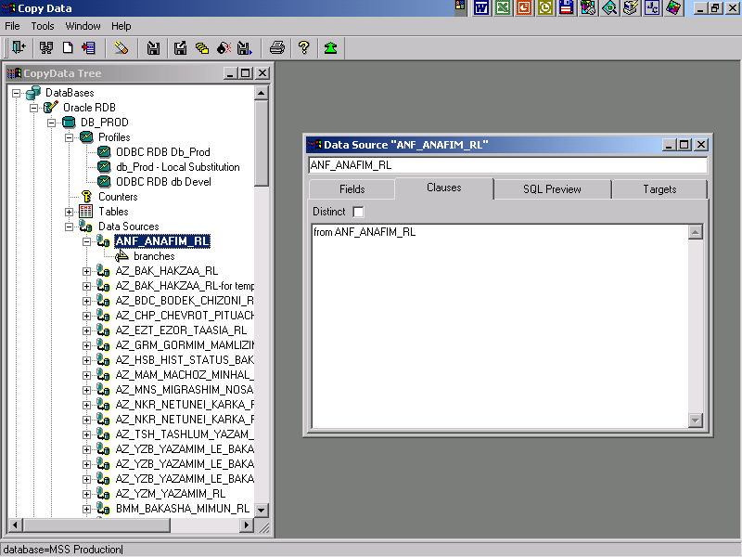

Screenshot 9.

CopyData Console. The chosen Data Source is opened. The “Clauses” page is presented.
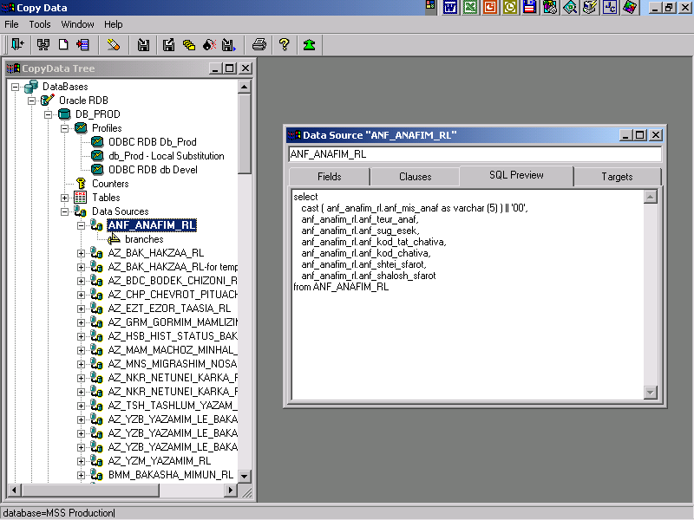

Screenshot 10.

CopyData Console. The chosen Data Source is opened. The “SQL Preview” page is presented.
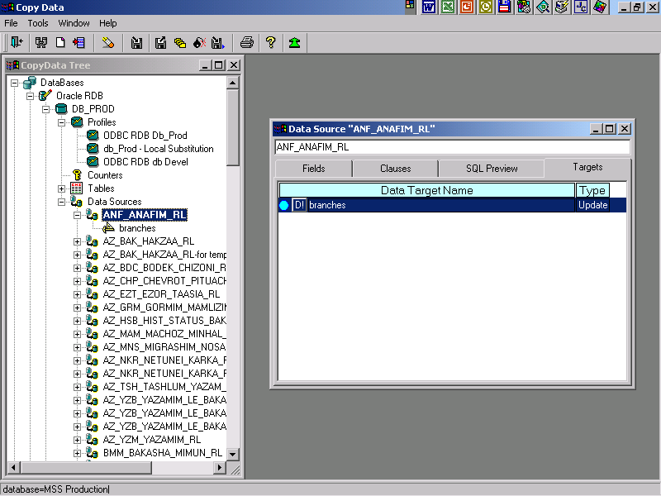

Screenshot 11.

CopyData Console. The chosen Data Source is opened. The “Targets” page is presented.
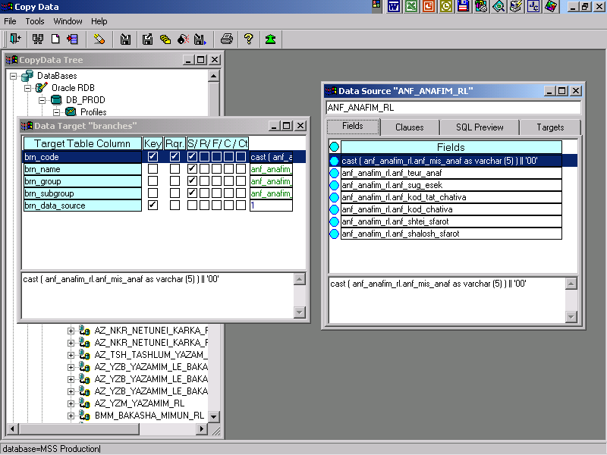

Screenshot 12.

CopyData Console. The Data Target for the Data Source is opened. From the “Fields” page of the Data Source a user can “Drag and Drop” a source field to bind it to a target field. In the same simple way Data Counters, Functions, Constants and fields from any other Data Target of the same Data Source can be bound to the Data Target field.
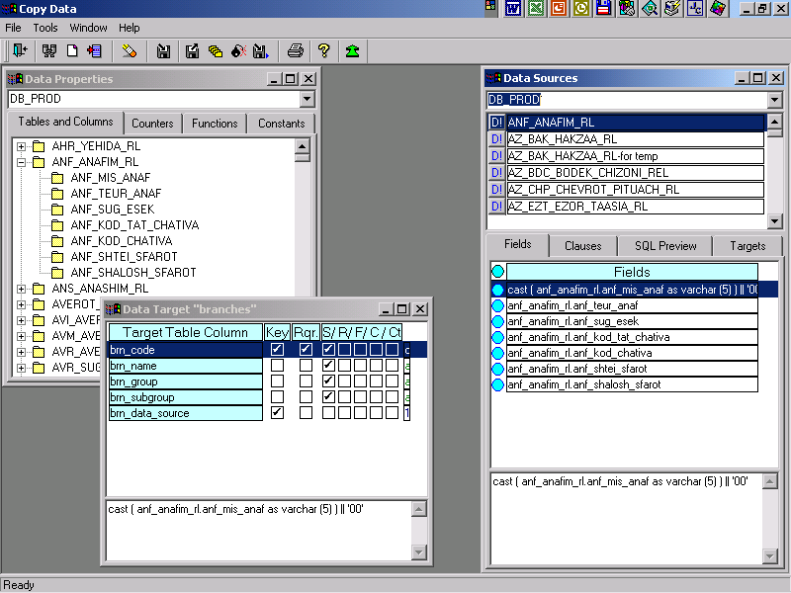

Screenshot 13.

Another point of view. Data Sources and Data Properties ( i.e. Tables and Columns, Data Counters, Functions and Constants ) are opened as individual windows.
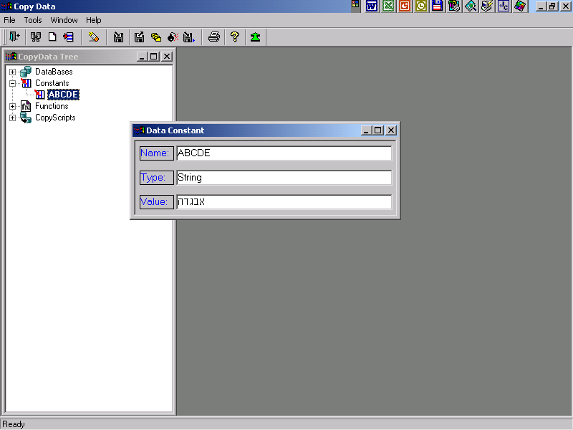

Screenshot 14.

CopyData Console. Data Constant definition.

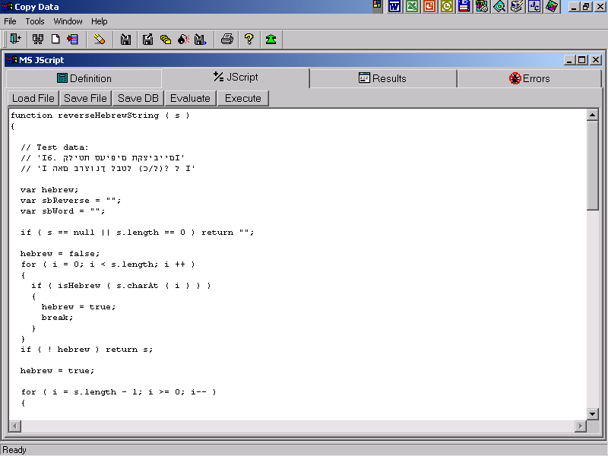

Screenshot 15.

JScript editor window. Can be opened from the CopyData console to define a function or from the application menu as JScript debugging window.
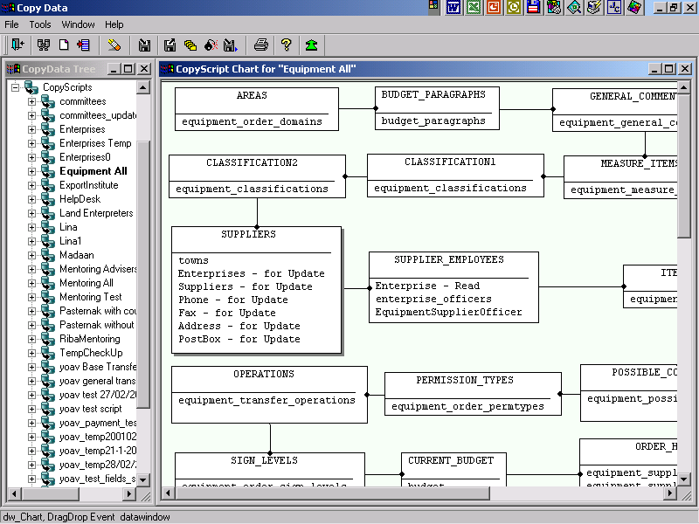

Screenshot 16.

CopyData Console. A Copy Script Chart. A Copy Script is a set of Copy Script Steps. A Data Source or an SQL Script can be Copy Script Steps.
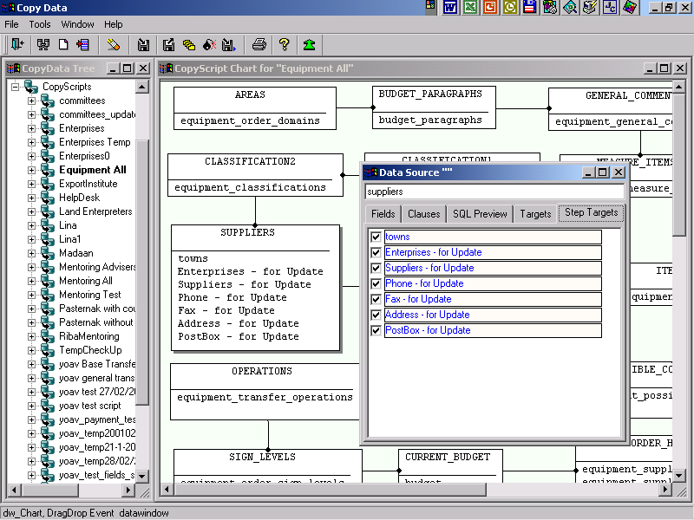

Screenshot 17.

CopyData Console. The chosen Copy Script Step of Data Source type is opened. A user can define which Data Targets and in which order will be used in this Copy Script Step.
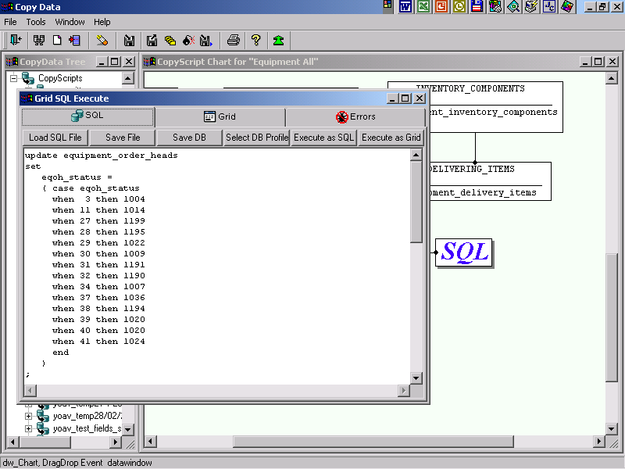

Screenshot 18.

CopyData Console. The chosen Copy Script Step of SQL Script type is opened. The SQL Script window also can be opened from the application menu for SQL debugging or for performing individual SQL actions on the chosen Database.
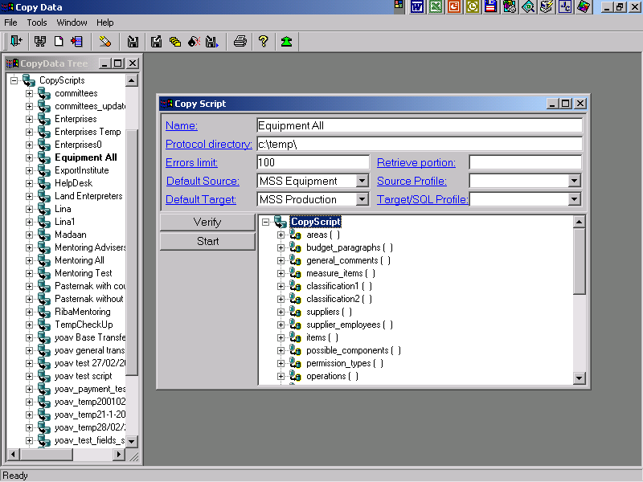

Screenshot 19.

CopyData execution of the chosen Copy Script.
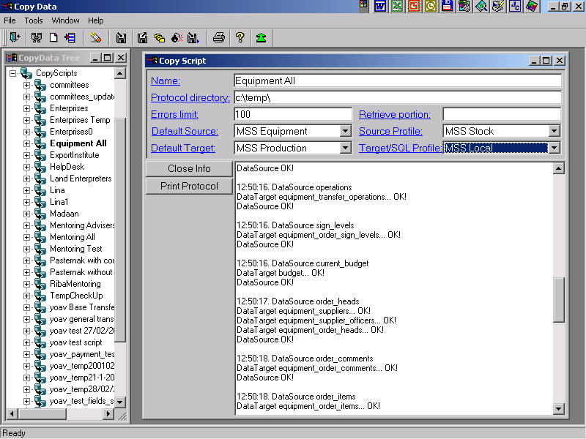

Screenshot 20.

CopyData execution in progress. The short CopyData protocol is presented in the window and the full CopyData protocol is saved in the protocol file.

